GitHub Copilot use cases: -

1. Auto Completing codes

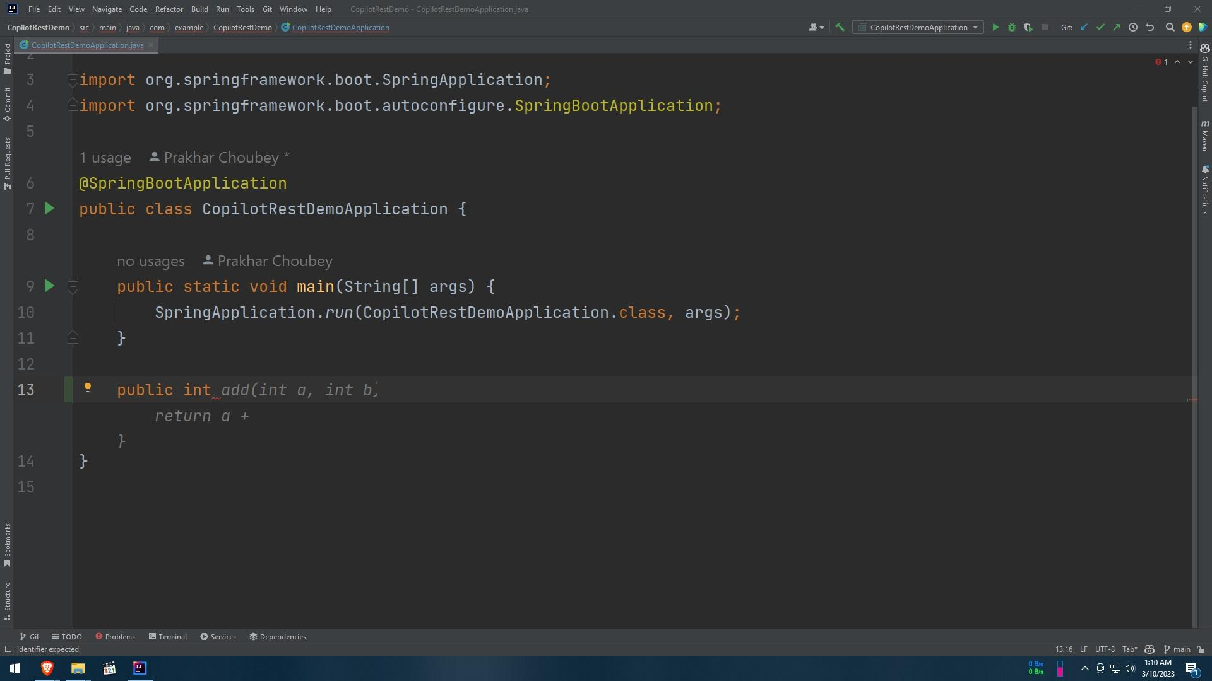

1. Suggests dummy data for objects and different data structures.

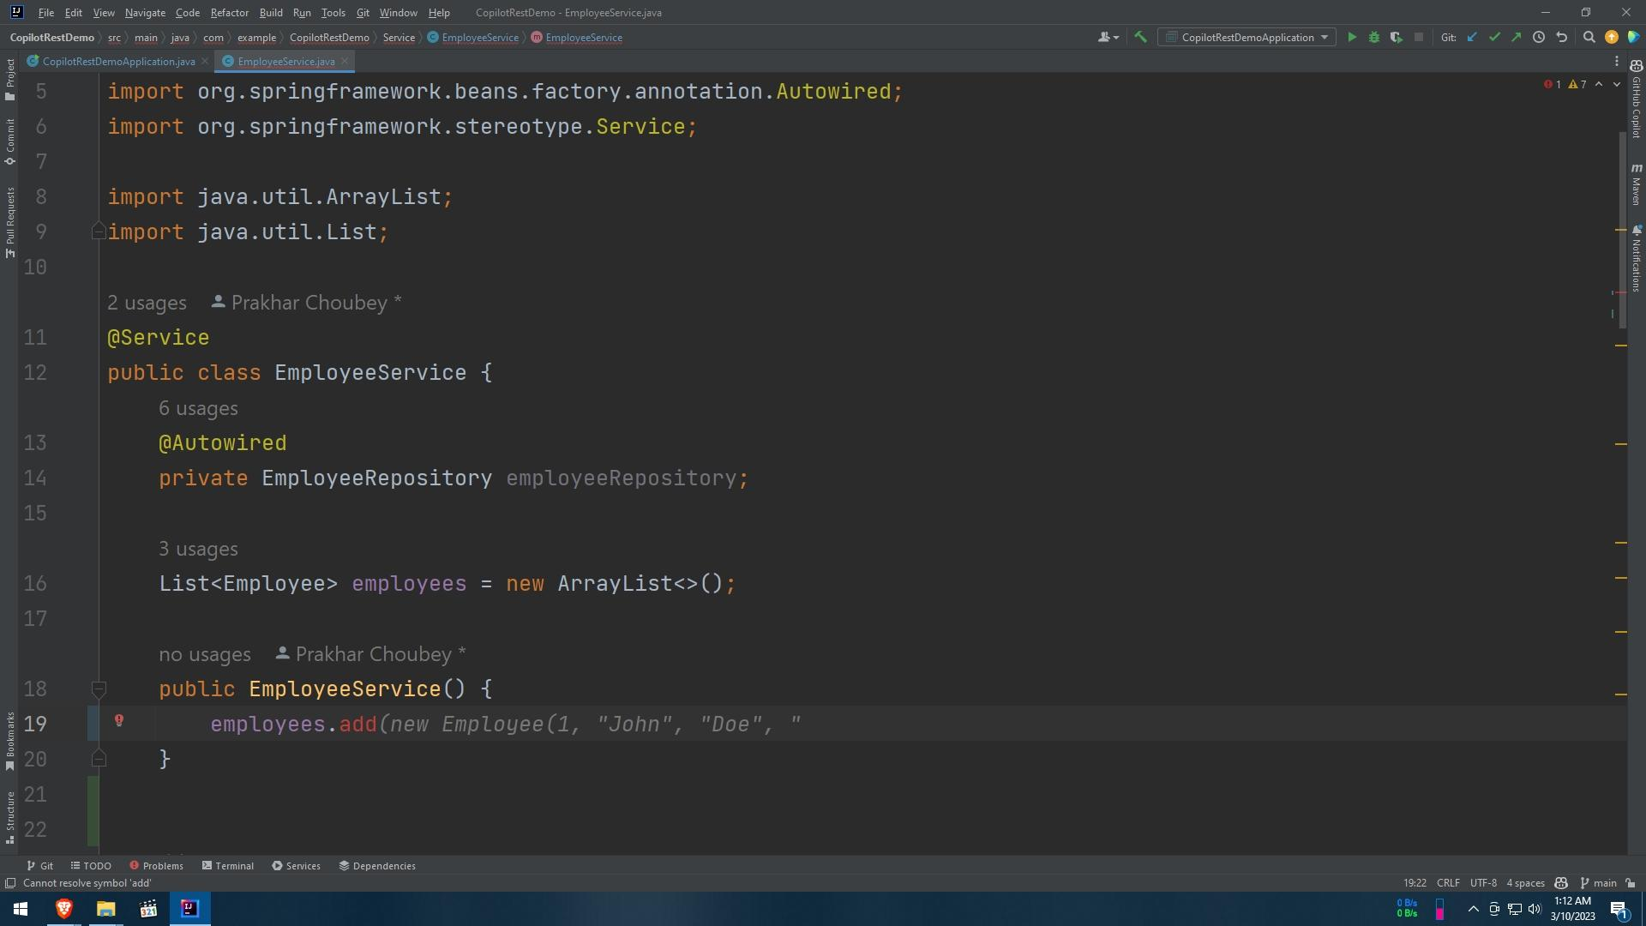

1. Suggest using our past-used codes.

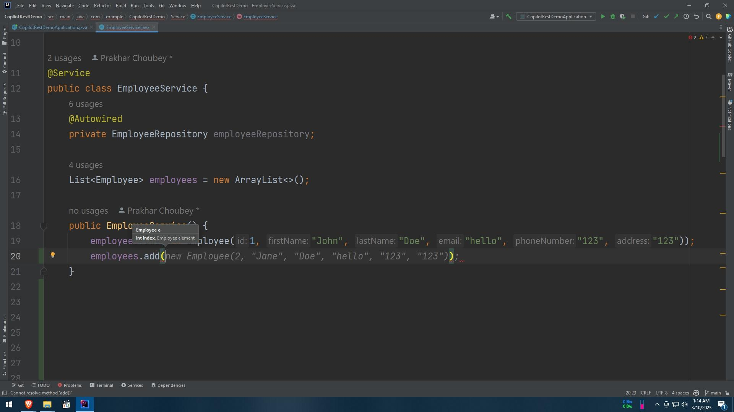

1. Generates return statement, by analyzing the prototype of the method.

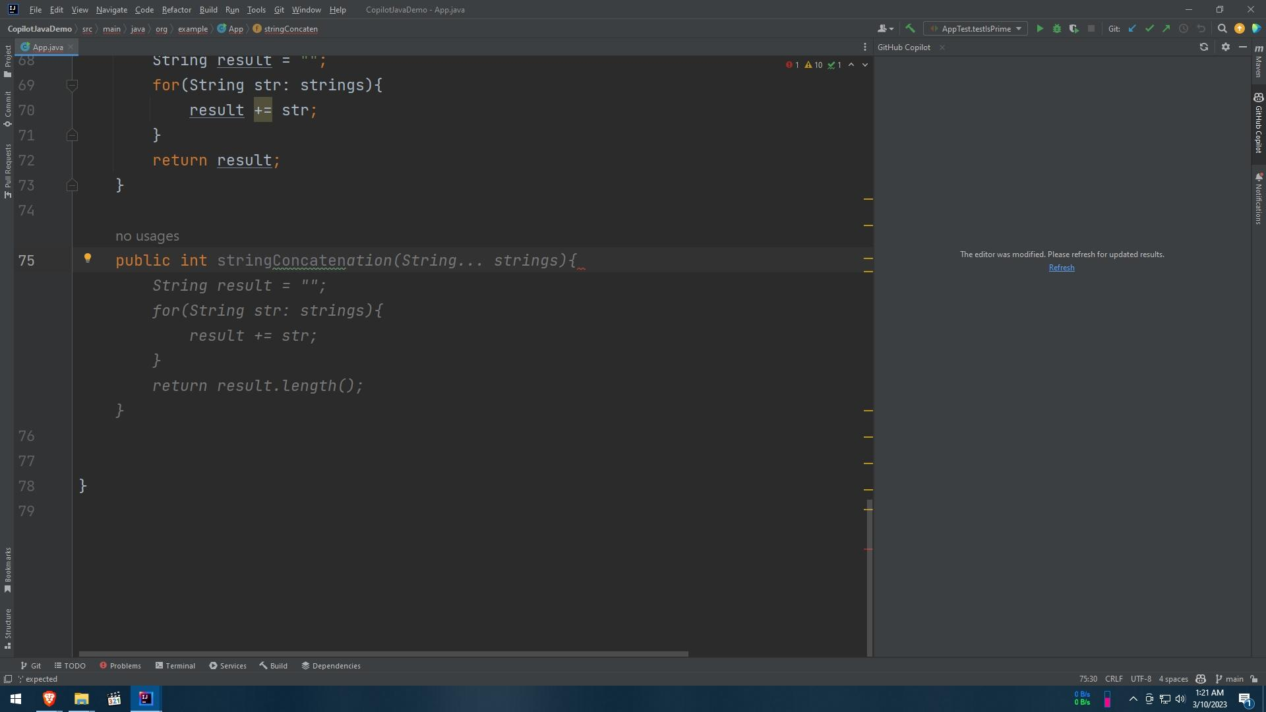

1. Generates full functions, just by writing a brief comment

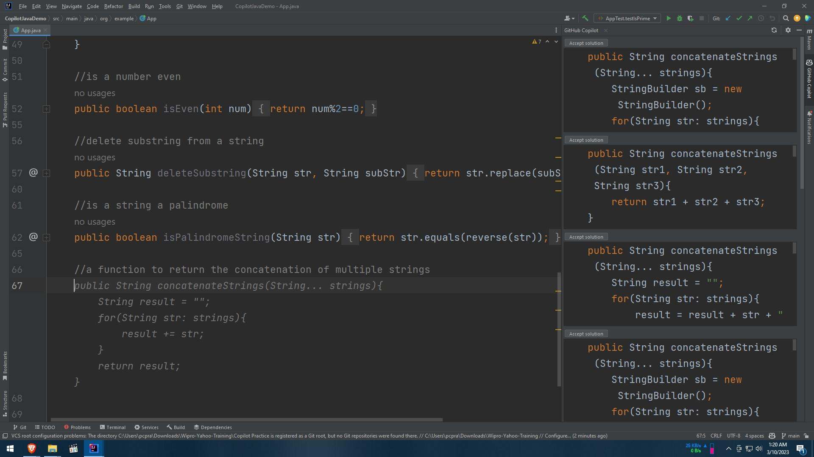

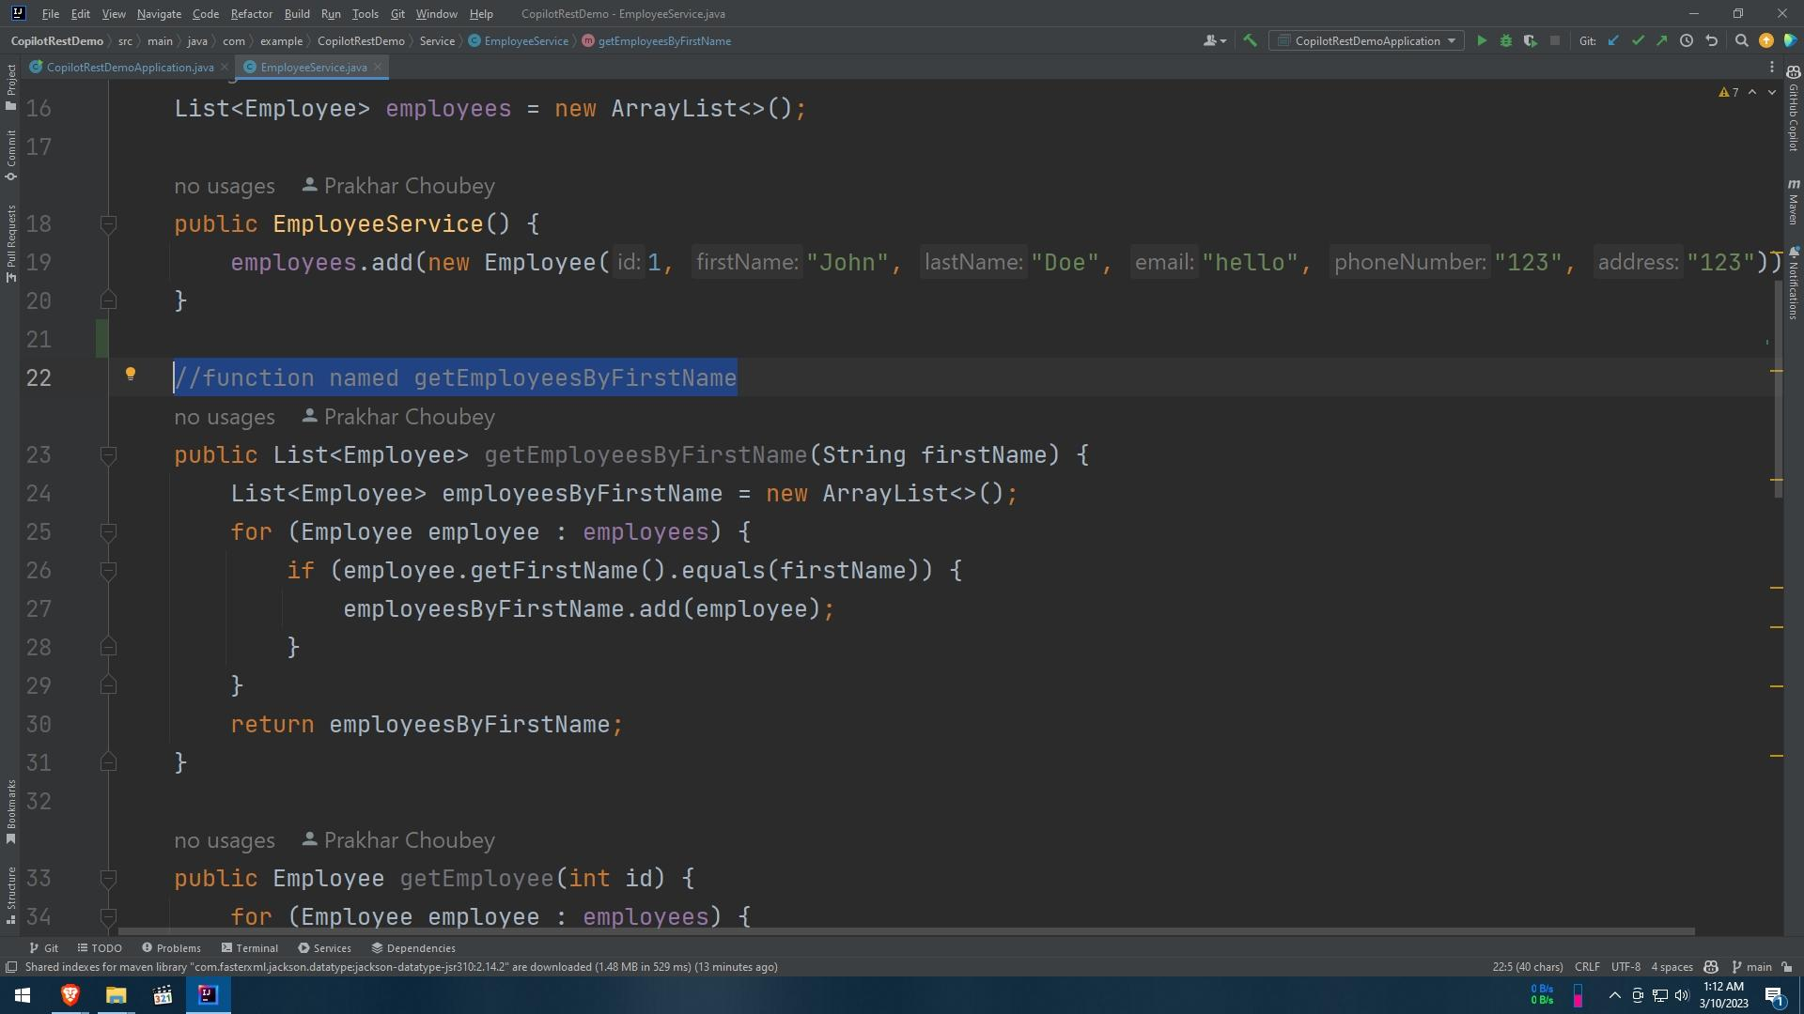

1. Generates test cases

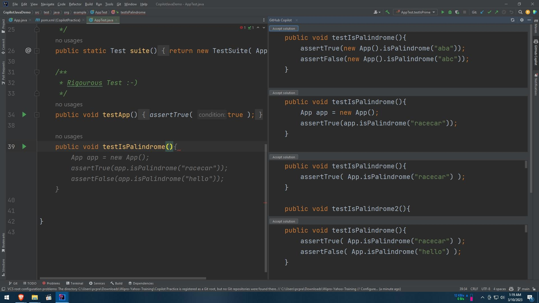

1. Allows us to choose from different suggestions.

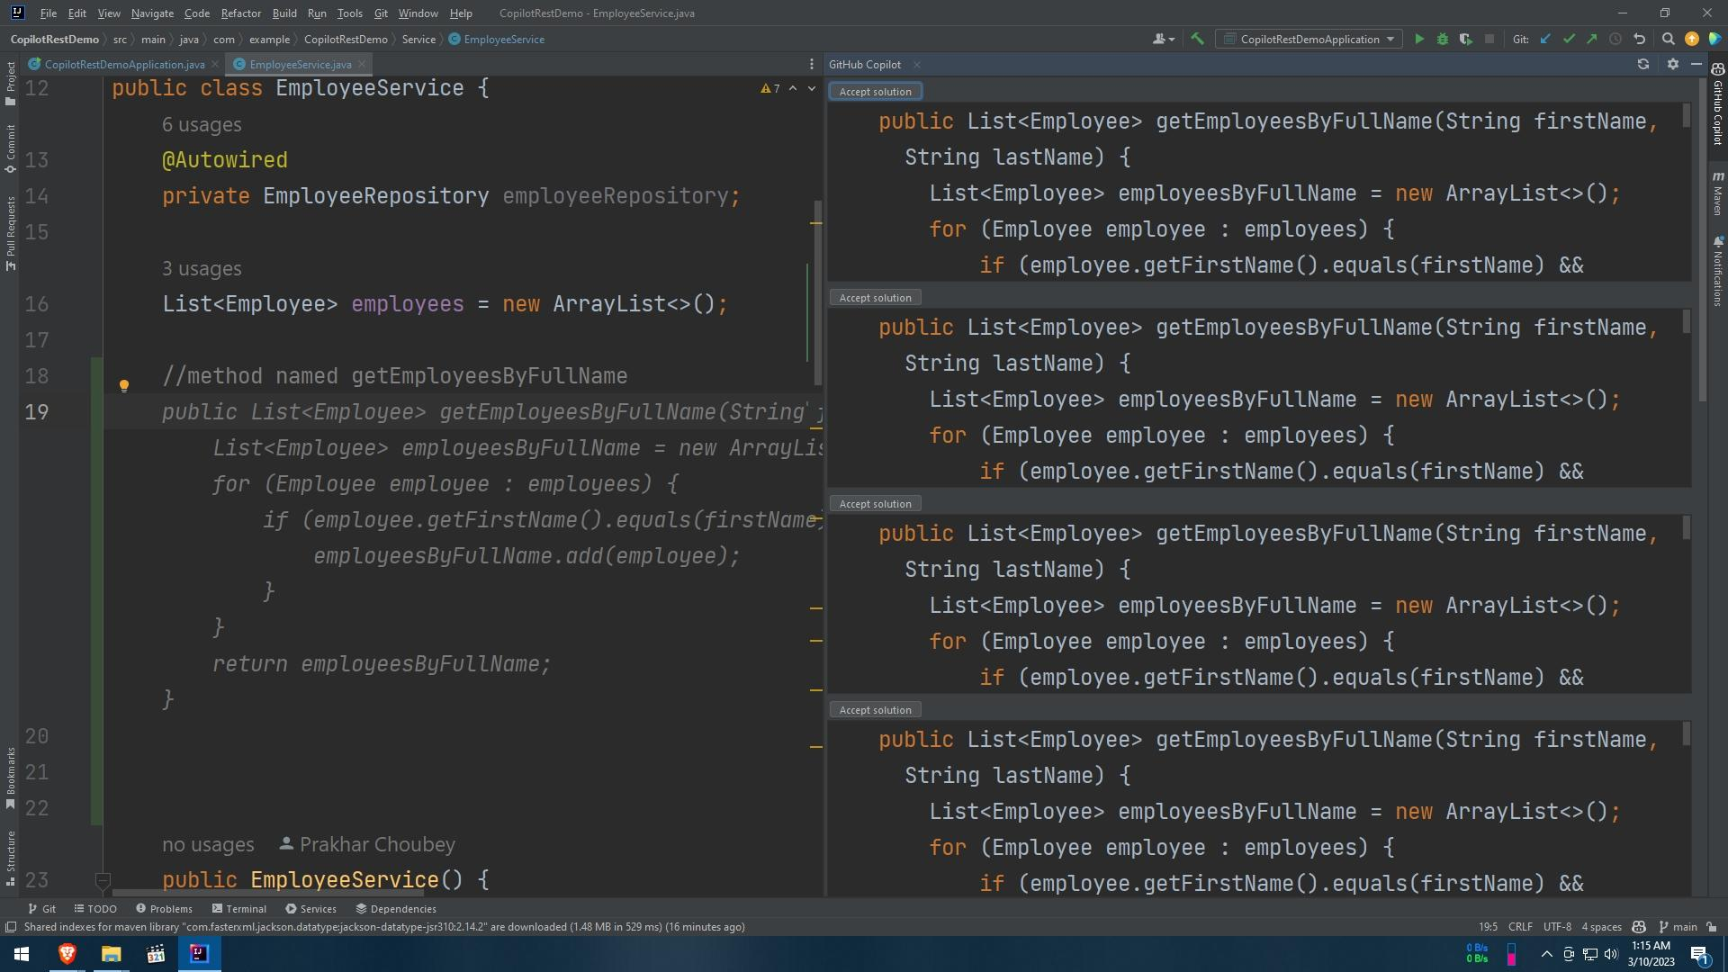

1. Shows suggestions of methods and data members according to the class name.

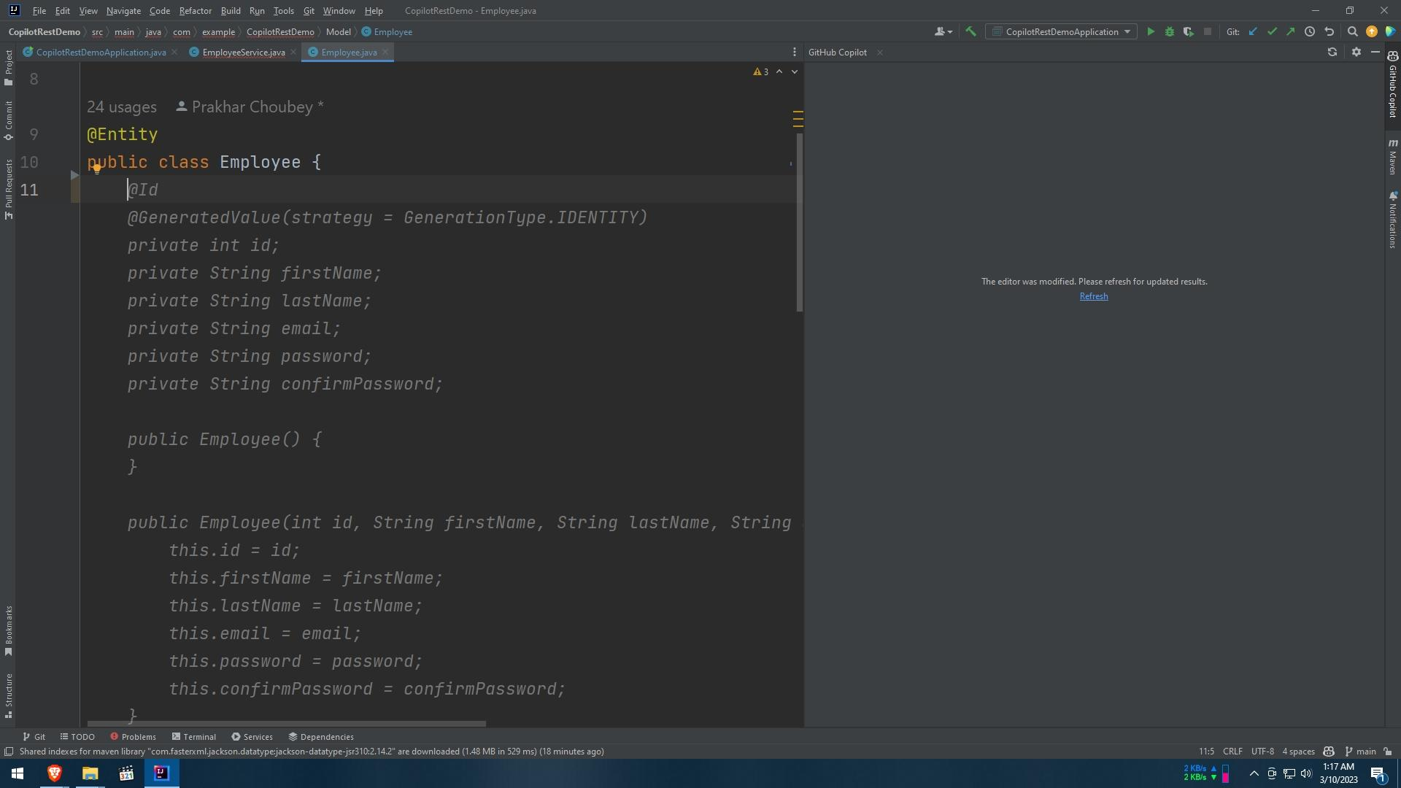

Problem Faced: -

1. The import statement needed to be added manually.
2. Annotations suggestions